1.

#include <iostream>

using namespace std;

int sum (int in)

{

int su=0,coun=1;

for (int i=1; i<=in; i++)

{

if (in%i==0)

{

if(coun%2==1)

su=su+i;

else

su=su-i;

coun++;

}

}

return su;

}

int main()

{

int in;

cin>>in;

cout<<sum(in);

return 0;

}

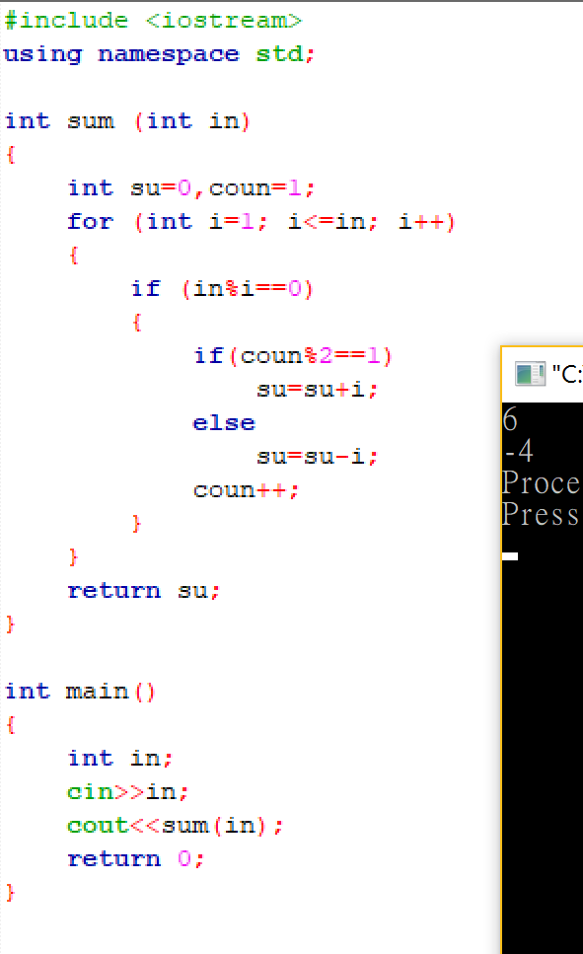

2.

#include <iostream>

using namespace std;

void number (int in)

{

int temp=1;

for (int i=1;i<=in;i++)

{

for (int j=1;j<=in-i;j++)

{

cout<<' ';

}

for (int k=1;k<=temp;k++)

{

cout<<i;

}

temp=temp+2;

cout<<endl;

}

}

int main()

{

int in;

cin>>in;

number(in);

return 0;

}

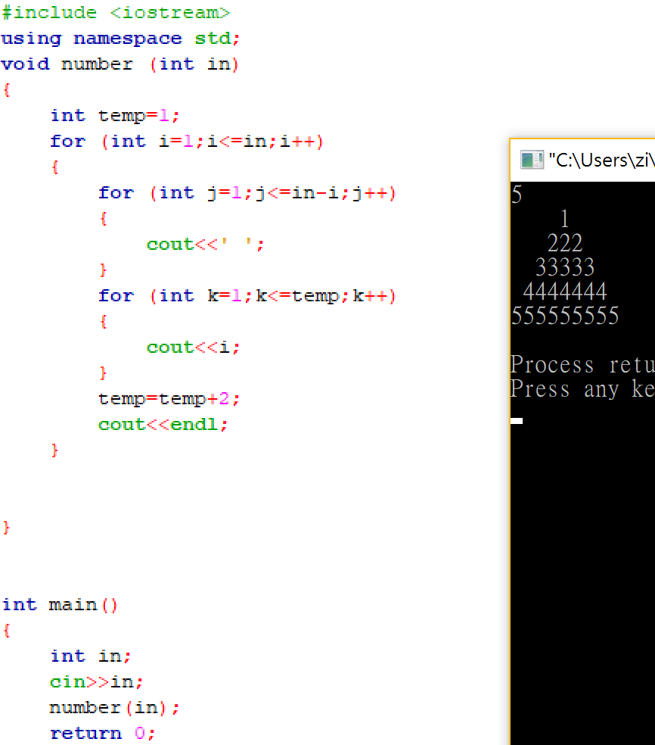

3.

#include <iostream>

#include <time.h>

#include <cstdlib>

int randnb (void)

{

int randnum =rand()%100;

}

using namespace std;

int main()

{

srand(time(0));

int in;

cin>>in;

for (int i=0;i<in;i++)

{

cout<<randnb()<<" ";

}

return 0;

}

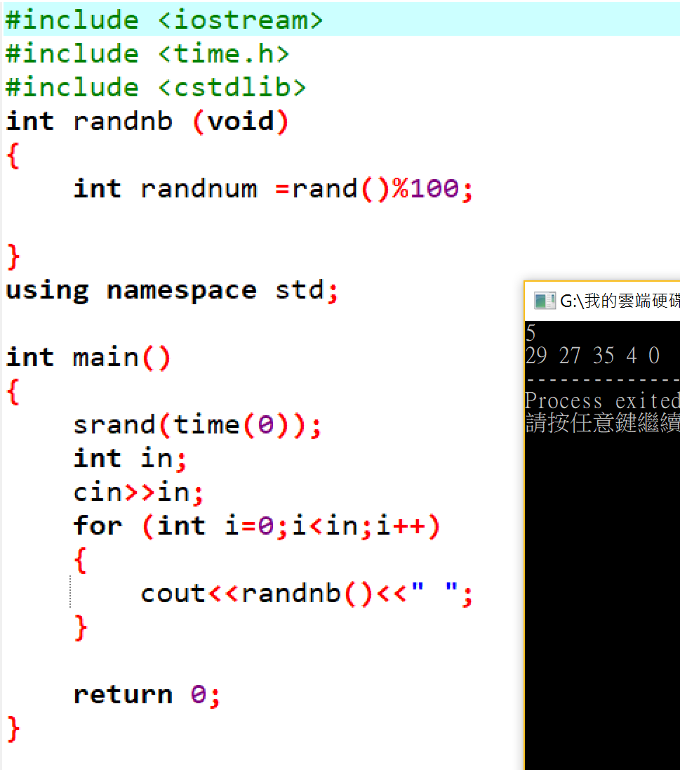

4.

#include <iostream>

using namespace std;

bool check (int in)

{

int arr[11]= {0};

int ans[11]= {0};

int i=0,sum=0;

do

{

arr[i]=in%10;

in=(in-arr[i])/10;

i++;

}

while(in!=0);

i=i-1;

for (int k=0; k<=i; k++)

{

if (arr[k]!=arr[i-k])

ans[k]=1;

}

for (int k=0; k<i; k++)

{

sum=sum+ans[k];

}

bool answer;

if (sum==0)

answer=0;

else

answer=1;

return answer;

}

int main()

{

int in;

cin>>in;

bool ans=check(in);

if (ans==0)

cout<<"YES";

else

cout<<"NO";

return 0;

}

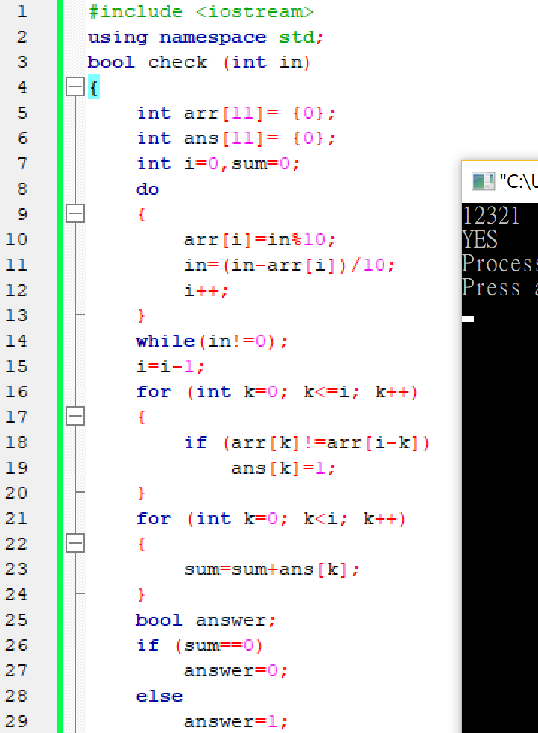

5.

#include <iostream>

using namespace std;

int main()

{

int bin [3][3]= {0};

int input,bingo=0;

for (int i=0; i<=2; i++)

{

cin>>input;

if (input==111)

bingo++;

for (int j=2; j>=0; j--)

{

bin[i][j]=(input%2);

input=(input-bin[i][j])/10;

}

}

for (int i=0;i<=2;i++)

{

if ((bin[0][i]==bin[1][i])&&(bin[1][i]==bin[2][i])&&(bin[1][i]==1))

bingo++;

}

if ((bin[0][0]==bin[1][1])&&(bin[1][1]==bin[2][2])&&(bin[1][1]==1))

bingo++;

if ((bin[0][2]==bin[1][1])&&(bin[1][1]==bin[2][0])&&(bin[1][1]==1))

bingo++;

if (bingo==0)

cout<<"NO";

else

cout<<"BINGO";

return 0;

}

